FRACTIONS OF AN AMOUNT
Pearson Edexcel - Tuesday 19 May 2020 - Paper 1 (Non-Calculator) Higher Tier
1.
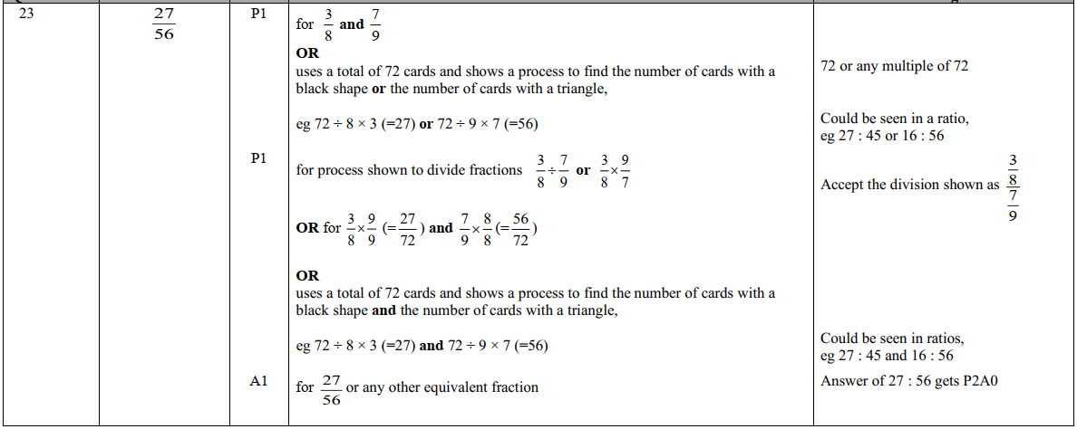
Pearson Edexcel - Tuesday 21 May 2019 - Paper 1 (Non-Calculator) Higher Tier
2.
